Group Project Business Case

Project Business Case

Frankford Recreational Center Construction Project

Innovative Project Solutions
March 6, 2020
PMAN 634 - 9080 - Spring 2020
Eleuterio Hechanova
Michael Kinsella
Jayna Kovel
Daniel Lewis

Change History

Date changed | Change details | Reason for change  (if applicable) | Responsible for change
March 1, 2020 | Document creation and delegation of roles | Project initiation | All group members

March 2, 2020 | Frankford Recreational Center Construction Project | Completion of intro to kick off assignment for other group members | Michael Kinsella

March 3, 2020 | Business Needs | Completion to allow time for recommendations and evaluation | Eleuterio Hechanova

March 4, 2020 | Recommendations/ Evaluation | Completion to allow time for references and Appendix and final edits | Daniel Lewis

March 5, 2020 | Change History Creation, Minor Edits | Working towards project first draft completion | Jayna Kovel

March 6, 2020 | Restructuring of Sections, Research Implementation, Analysis of Situation and Final Edits | First draft completion | Jayna Kovel

Table of Contents
Title Page 1
Change History 2
Table of Contents 3
Project Introduction 4
Business Needs 4
Analysis of Situation 5
Recommendations and Evaluation 6
References 9
Appendix 11

Frankford Recreational Center Introduction of Projet
The city of Frankford, Maryland is in need of a new recreation/community center. The current building is severely dilapidated, and positioned in a part of town that is no longer the epicenter of city residences. The city is interested in building a fully updated and readily accessible community center to provide services to the community as a whole, with a heavy focus on programming available to children and adolescents. A new recreation center with public services catered toward the youth will provide a secure environment for all to learn and grow - allowing the ability to develop important life skills and good habits.

Business Needs
There is a well documented historical theory that providing preventative measures to a community in the form of social service is a worthwhile investment. In scholarly texts, we see examples such as Samuel O. Wynne recommending the conversion of public high schools into public recreation centers as early as 1926. Wynne’s (1926) thought process was much in line with the current political climate of today, that prison is not always an effective deterrent to crime, and the answer instead lies within community programming such as education, job training, and limited exposure to elements that breed crime such as a lack of resources. While this theory has been expanded upon and put into practice throughout the United States since the early theoretical days, do the results support Wynne’s hypothesis?
It appears that Wynne’s hypothesis is indeed supported by the research, with one caveat; the community programing must be highly organized. Kurtz (2015) found through his research that youths that take part in extracurriculars are more likely to show increased confidence and leadership skills, improvements in academics, and lower rates of negative behavioral patterns. Additionally, the research suggested these negative behavioral patterns can actually be enhanced if the programming offered in the recreational centers was not structured, and that no patterns were clearly recognizable amongst any specific geographic region. With this research in mind, it is clear the restructuring of the Frankford Recreational Center will be an asset to the youth, and beneficial to the community as a whole.
While the resource and time requirements to build a community recreation center can be substantial, the Frankford Recreational Center will serve as a thriving hub of activity for youth, families, senior citizens, civic organizations, parks and recreation. It will provide the community with a centralized location to promote strong relationships through sports leagues, academic assistance, access to social development and community projects, and so much more. While the main clientele the center will aim to serve will be the youth of the community, the multi-purpose space will also benefit working parents by providing a range of after school programming, at risk families through the community food bank, senior citizens through a myriad of social clubs and physical fitness clubs and classes, and so much more. The reestablishment of the rec center will provide much needed resources and amenities that currently do not exist and help strengthen and reestablish the Frankford community.
Analysis of Situation
Living in Frankford (2015) indicates that the community scores well in things such as affordability and diversity, it has higher crime rates than many communities in the surrounding areas. A major goal of the reestablishment of a recreational center in the community is to provide services to help decrease the appeal of interacting with community members in this way. As referenced in Henderson et al. (1999), "leisure activities can play an instrumental role if certain key components exist, such as quality programming, caring and supportive adults, and quality social interactions." The leisure activities the community could provide for community members, and particularly the youth and young adults within the community, will provide a positive outlet to help invigorate the community. Through our analysis and research, the cause and effect relationship we are aiming to build is evidenced in the figure below (Witt et al. 2015):
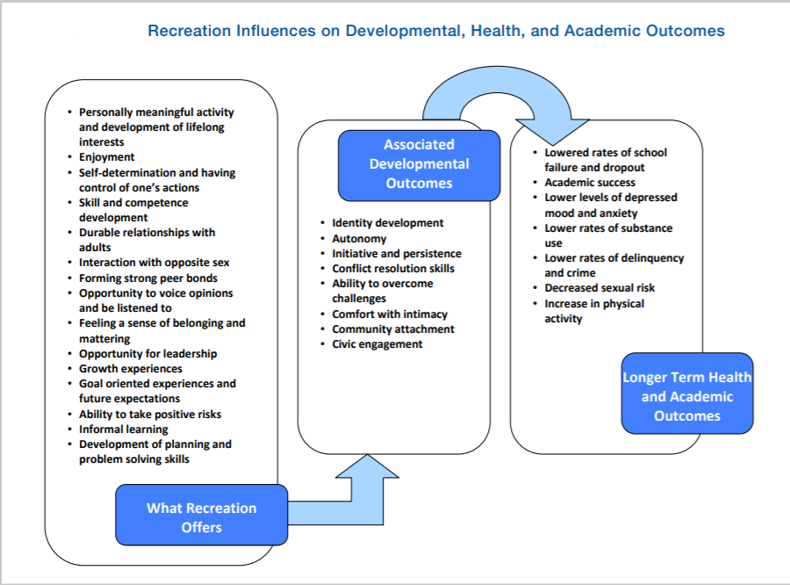

Recommendations and Evaluation
In Innovative Project Solutions, we have several strategies to help improve the community. Our first objective is to build partnerships with local governments, real estate developers and neighborhood leaders. In creating these partnerships, we build a stream of quality local products and services to provide at a decent price. It also will secure the funding in completing the community facility. Community leaders will be key, as they will be our partners in acquiring this facility as well as the permits to build it out. The communication between community leaders and local government will provide key data to the project managers. The community leaders will be able to provide qualitative and quantitative data gathered by the community to gauge the interest of this project. Real estate developers will benefit from the rec center through the development of community programming, which increases property values. Once the team has cultivated these partnerships, we will move on to our second facet of our strategy.
Phase two of our strategy is developing an action plan to increase resources and opportunities for the community as a whole. Ideally, community residents of all ages will have a centralized location to keep them active, engaged in the community, and provide necessary resources for all people within the community to thrive. Volunteer assignments for community members to mentor youth will increase community engagement and development. We will also provide opportunities for community members to maximize career and educational opportunities.
There are several risks to consider when developing a plan for a project of this scale. The first risk is obtaining the resources and financial support necessary to complete a non-profit project of this sort. Whether the resources are tangible, such as money or construction materials, or intangible such as volunteers from the community, resources are without a doubt the project’s largest hurdle to scale. We plan to supplement the project through a series of government grants and the funds made available to us from the community taxes allocated towards projects of this nature, and sourcing intangibles like volunteers from local high schools, colleges, and leaders within the community.
When considering the Frankford Recreational Center, it is also important to consider existing market competitors and potential disruption in the market. As an example, Frankford has many health clubs which could directly compete with the sports leagues we hope to develop. This risk will be mitigated by offering specialized and unique services and also cost efficiency packages that will best meet our consumers through the partnerships established.
Through developing relationships in the community, establishing the finances necessary to structure the program, and ensuring we have adequate programing opportunities and volunteers to staff said programs, we will build a safe haven for the Frankford community.
There are milestones that will be accomplished to ensure we remain on track for our scheduled opening on September 1st. On March 15th, we will have established a formal meeting with local community leaders and local governments. On May 1st, we hope to have fiscal funding from fundraisers, government grants, and local leaders to purchase the property. By June 5th, we will complete a survey of the property that we will be converting from an abandoned warehouse into the community’s new recreational center, by way of which we will establish the necessary insurance and permits needed to begin construction. By June 15th, we will initiate project construction. By August 25th, the final building will be created and inspected for final review. By September 1st, we will have a grand opening of the community center and invite everyone in the community to come join the celebration.

References
Henderson, K. A., & King, K. (Kat). (1999). Youth Spaces and Places: Case Studies of
Two Teen Clubs. Journal of Park & Recreation Administration, 17(2), 28–41.
Kurtz, D. (2015, September). Structured recreation programming can help reduce
juvenile crime. Parks & Recreation, 50(9), 82. Retrieved from https://link-gale-com.ezproxy.umuc.edu/apps/doc/A430271300/AONE?u=umd_umuc&sid=AONE&xid=75010e0c
Living in frankford. (2015, April 04). Retrieved March 06, 2020, from
https://www.niche.com/places-to-live/n/frankford-baltimore-md/
Project Management Institute. (2017). A Guide to the Project Management Body of
Knowledge (PMBOK® Guide) — Sixth Edition and Agile Practice Guide (ENGLISH). Retreived from https://search-ebscohost-com.ezproxy.umuc.edu/login.aspx?direct=true&db=nlebk&AN=1595321&site=eds-live&scope=site
Witt, P. A., & Caldwell, L. L. (2010). The rationale for Recreation services For YOUTH:
An evidenced based approach. National Recreation and Park Association. Retrieved March 06, 2020, from https://www.researchgate.net/profile/Peter_Witt5/publication/280089228_The_rational_for_recreation_services_for_youth_An_Evidenced_Based_Approach/links/55a7bf2508ae8c884951f716/The-rational-for-recreation-services-for-youth-An-Evidenced-Based-Approach.pdf.
Wynne, S. O. (1926). Recreation centers as a means of crime prevention. The ANNALS of
the American Academy of Political and Social Science, 125(1), 175-176. doi:10.1177/000271622612500133

Appendix
Simplified Scoring Model
 |  |  | (A) |  | (B) |  | (A) x (B)
Project | Criteria |  | Importance Weight |  | Score |  | Weighted  Score
Frankford Recreational Center |  | Cost  ROI  Org Fit  Risk  Total Score |  | 3  2  3  2 |  | 6  2  7  3 |  | 18  4  21  6  49
Condominium Development |  | Cost  ROI  Org Fit  Risk  Total Score |  | 1  3  3  2 |  | 5  3  4  2 |  | 5  9  6  8  28
Strip  Mall |  | Cost  ROI  Org Fit  Risk  Total Score |  | 2  1  3  2 |  | 5  5  2  4 |  | 10  5  6  8  29

